PROPOZICIJE
CIRKULARNA IZLOŽBA UMETNIČKE FOTOGRAFIJE
PHOTON 2024
SRBIJA I CRNA GORA

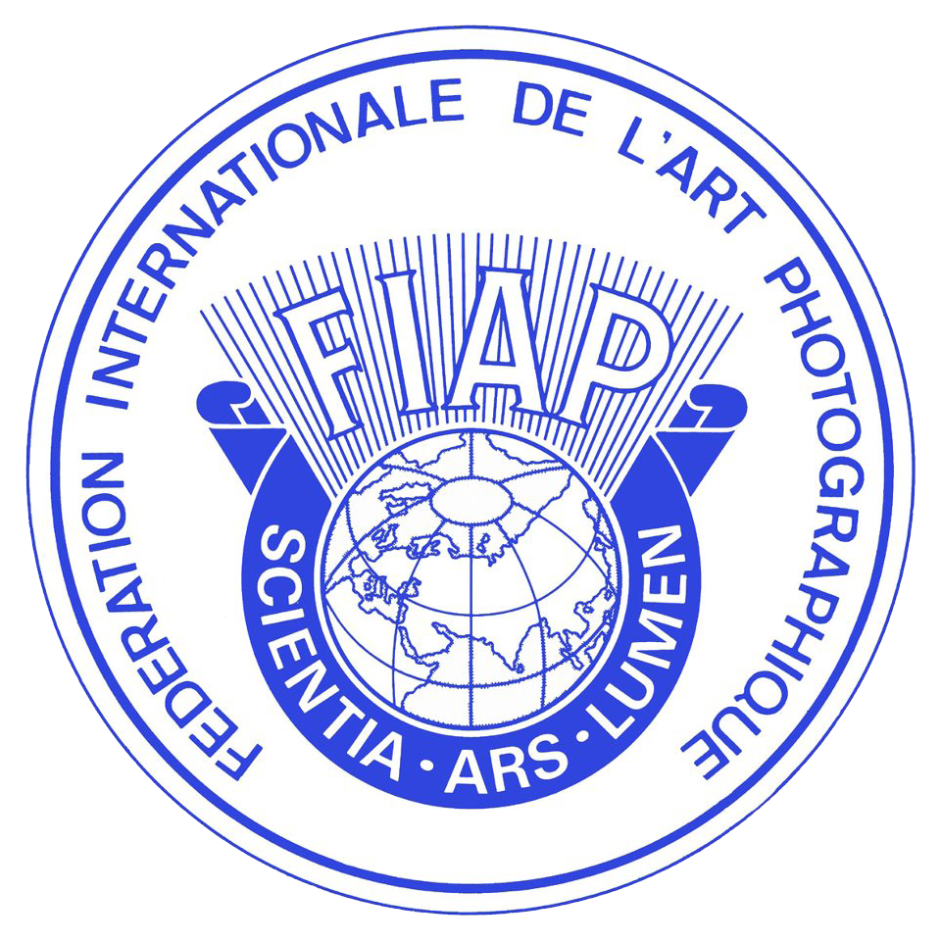

ORGANIZATOR
FK Olcinium – Crna Gora, FK Šimanovci i FK Objektiv - Srbija
Šef salona: Oliver Vukmirovic
Email organizatora: photoclubsimanovci@gmail.com
https://photon.photomagart.com

TEME

U 4 sekcije, sve digitalne:

- OTVORENA KOLOR (samo kolor - digitalna)
- OTVORENA MONO (samo monohrom - digitalna)
- PORTRET (kolor i monohrom - digitalna)
- PRIRODA (kolor i monohrom - digitalna)

Svaka fotografija može biti predstavljena samo u jednoj temi/sekciji.

KOTIZACIJA

- bilo koje 1 or 2 sekcije = 25 EUR (25 $USD)
- bilo koje 3 or 4 sekcije = 30 EUR (35 $USD)

PayPal za plaćanje on-line (photoclubsimanovci@gmail.com).
Radovi autora koji ne plati kotizaciju neće ući u razmatranje.

GRUPNO UČEŠĆE
Popust za grupe:
- 5-10 učesnika = 10%
- 11-20 učesnika = 20%
- 21-30 učesnika = 30%

KALENDAR

Datum zatvaranja: 14.01.2024.
Završetak žiriranja sa 01.02.2024.
Slanje obavještenja do 14.02.2024.
Slanje nagrada do 01.04.2024.
On-Line galerija: 14.02.2024.
Katalog: 01.04.2024.
Datum izložbe: Ulcinj: 08.03.2024; Šimanovci: 11.03.2024. i Kragujevac: 15.03.2024.

ŽIRI

ULCINJ SALON
- Biljana Latinovic, EFIAP – Bosna i Hercegovina
- Slobodan Cavic, EFIAP, EPSA - Srbija
- Marjan Janevski, AFIAP – Severna Makedonija

ŠIMANOVCI SALON
- Goran Kojadinovic, EFIAP/s, PPSA - Srbija
- Aleksandar Tomulic, EFIAP - Hrvatska
- Dimitar Chungovski - Severna Makedonija

KRAGUJEVAC SALON
- Sasa Blagojevic, PPSA, EFIAP – Srbija
- Goran Starcevic – Bosna i Hercegovina
- Zoran Zdravev, EPSA - Severna Makedonija

NAGRADE

ULCINJ SALON
- 4x FIAP Gold Medals and 8x FIAP Blue Ribbons
- 4x PBA Black Medals and 12x PBA Digital Diplomas
- 12x MAPA Digital Diploma
- 4x SALON Gold Medal, 4x SALON Silver Medal, 4x SALON Bronze Medal
- 24x SALON Digital Diploma
- 12x IAAP Diploma
- FIAP Blue Badge
- SALON Best Author

SIMANOVCI SALON
- 4x FIAP Gold Medals and 8x FIAP Blue Ribbons
- 4x PBA Black Medals and 12x PBA Digital Diplomas
- 12x MAPA Digital Diploma
- 4x SALON Gold Medal, 4x SALON Silver Medal, 4x SALON Bronze Medal
- 24x SALON Digital Diploma
- 12x IAAP Diploma
- FIAP Blue Badge
- SALON Best Author

KRAGUJEVAC SALON
- 4x FIAP Gold Medals and 8x FIAP Blue Ribbons
- 4x PBA Black Medals and 12x PBA Digital Diplomas
- 12x MAPA Digital Diploma
- 4x SALON Gold Medal, 4x SALON Silver Medal, 4x SALON Bronze Medal
- 24x SALON Digital Diploma
- 12x IAAP Diploma
- FIAP Blue Badge
- SALON Best Author

Ukupno 270 nagrada. Svaki autor može dobiti samo jednu nagradu u svakoj sekciji.

KATALOG

Organizator će proizvesti PDF katalog spreman za preuzimanje od strane izlagača putem vebsajta https://photon.photomagart.com.

OBAVEŠTENJE

Obaveštenja će biti poslata putem email. Organizator neće preuzimati odgovornost oko uručenja pošte i nagrada, usled oštećenja ili gubitka u transport. Rezultati takmičenja će biti objavljeni na veb sajtu https://photon.photomagart.com

PARTICIPATION
The exhibition is open to anyone; however, an entry may be rejected when the sponsoring organization or its agent, in its reasonable discretion, believes the entry does not conform to the exhibition rules and conditions.
An entrant’s images will not be presented to the judges consecutively. An entrant’s four images will be distributed throughout four rounds of judging in that section. Distribution of images shall be in the same round order as submitted by the entrant.
Entries must originate as photographs (image-captures of objects via light sensitivity) made by the entrant on photographic emulsion or acquired digitally. By virtue of submitting an entry, the entrant certifies the work as his own (aliases are not permitted). The entrant permits the sponsors to reproduce all or part of the entered material free of charge for publication and/or display in media related to the exhibition. This may include low resolution posting on a website. Note: Entrants who indicate that their images may not be reproduced or used “will not be eligible for awards” or inclusion in audio-visuals of the exhibition “and could be subject to disqualification” by the exhibition sponsors.
Words such as “Untitled” and “No Title” are not acceptable as part or all of an image’s title, nor are camera capture filenames.

SUBMISSION
Photographs must be in JPEG format, with dimensions horizontal 1920 x vertical 1080 pixels at 300 DPI, JPEG compression (if Photoshop used for export): 7-12, file size maximum 4 Mb. No file naming is needed. Digital images cannot be altered, including resizing in either direction, by the exhibition or by the exhibition’s equipment before or during judging.
The photographs of authors with the application are submitted in these ways:
- uploading thought our web site: https://photon.photomagart.com

DEFINITIONS
FIAP Definition of Monochrome
A black and white work fitting from the very dark grey (black) to the very clear grey (white) is a monochrome work with the various shades of grey. A black and white work toned entirely in a single colour will remain a monochrome work able to stand in the black and white category; such a work can be reproduced in black and white in the catalogue of a salon under FIAP Patronage. On the other hand a black and white work modified by a partial toning or by the addition of one colour becomes a colour work (polychrome) to stand in the colour category; such a work requires colour reproduction in the catalogue of a salon under FIAP Patronage.

FIAP Nature Definition
Nature photography records all branches of natural history except anthropology and archaeology. This includes all aspects of the physical world, both animate and inanimate, that have not been made or modified by humans.
Nature images must convey the truth of the scene that was photographed. A well-informed person should be able to identify the subject of the image and be satisfied that it has been presented honestly and that no unethical practices have been used to control the subject or capture the image. Images that directly or indirectly show any human activity that threatens the life or welfare of a living organism are not allowed.
The most important part of a Nature image is the nature story it tells. High technical standards are expected and the image must look natural. Adding a vignette or blurring the background during processing is not allowed.
Objects created by humans, and evidence of human activity, are allowed in Nature images only when they are a necessary part of the Nature story.
Photographs of human-created hybrid plants, cultivated plants, feral animals, domesticated animals, human-created hybrid animals and mounted or preserved zoological specimens are not allowed.
Images taken with subjects under controlled conditions, such as zoos, are allowed.
Controlling live subjects by chilling, anaesthetic or any other method of restricting natural movement for the purpose of a photograph is not allowed.
No modification that changes the truth of a Nature image is allowed. Images may be cropped but no other technique that removes, adds or moves any part of the image is allowed.
Techniques that remove elements added by the camera, such as dust spots, digital noise and lens flare are allowed.
Complete conversion of colour images to greyscale monochrome is allowed. Partial conversion, toning and infrared captures or conversions are not allowed. Images of the same subject that are combined in-camera or with software by focus stacking or exposure blending are allowed. Multiple images with overlapping fields of view that are taken consecutively and combined in-camera or with software (image stitching) are allowed.

FIAP NOTICE

I hereby expressly agree to the FIAP document 018/2017 «Conditions and regulations for FIAP Patronage» and FIAP document 033_2021 «Sanctions for breaching FIAP regulations and the red list» I am particularly aware of chapter II «Regulations for International photographic events under FIAP patronage» of FIAP document 018/2017, dealing under Section II.2 and II.3 with the FIAP participation rules, the sanctions for breaching FIAP regulations and the red list.

.

